**FIRST ASSIGMENT**

SYTEM MANAJEMEN BASIS DATA



Disusun oleh:

|  |  |  |
| --- | --- | --- |
| Nama | : | Assyati Amadjida T.M. |
| NIM | : | L200164006 |
| Kelas | : | X |

**FAKULTAS KOMUNIKASI DAN INFORMATIKA**

**UNIVERSITAS MUHAMMADIYAH SURAKARTA**

**2018**

**TABLE RELATION OF CLASSIC MODELS**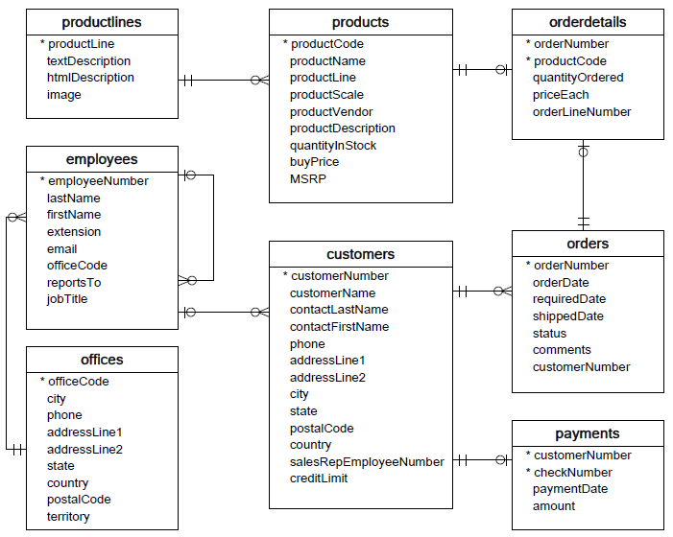

**THE RELATION OF TABLES**

* Productlines to Product   
  a. Relationship : One-to-Many(1:m)  
  b. A productlines have more than 1 product  
  c. A product only have 1 producline
* **Products to Orders**  
  a. Relationship : Many-to-Many(m:n) because their have primery key in table orderdetails  
  b. A product could have order many times  
  c. An order could contain of many product
* **Customers to Orders**  
  a. Relationship : One-to-Many(1:m)  
  b. A customers can make many order  
  c. An orders only can made by customers in one time
* **Customers to payments**  
  a. Relationship : One-to-Many(1:m)  
  b. A customers can make many payments  
  c. A payments only can make by the customers one time
* **Customers to employees**a. Relationship : Many-to-One(m:1)  
  b. A customers only serve one employee  
  c. A employee could give service to many customers
* **Employees to Offices**  
  a. Relationship : Many-to-One(m:1)  
  b. An employees only have an office   
  c. An office can work many employees
* **Employees to employees**  
  a. Relationship : Oney-to-Many(1:m)